Date | 5 Feb 2026
Team ID | LTVIP2026TMIDS24922
Project Name | Toycraft Tales: Tableau's Vision into Toy Manufacturer Data
Marks | 2 Marks

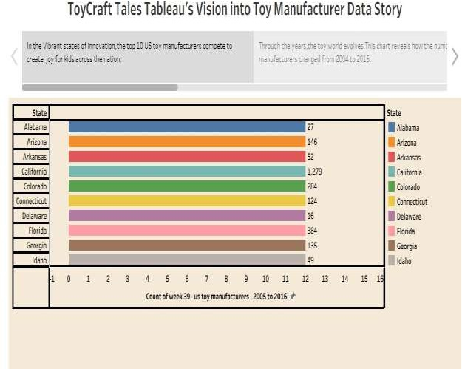

https://public.tableau.com/app/profile/jyoshna.k4074/viz/ToyCraftTalesstory/Story2?publish=y es

